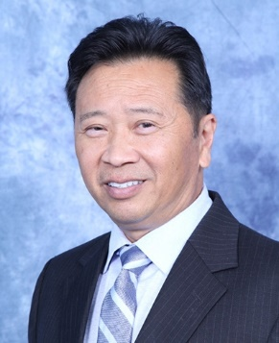
Michael Yee
CFP®, CRPC™, CFS®, CLTC®
Private Wealth Advisor
CERTIFIED FINANCIAL PLANNER™ practitioner

39 Years of Experience
This number may include years as a financial advisor, and/or experience as a registered representative.
Na Ho'okele Financial Advisory Team
A financial advisory practice of Ameriprise Financial Services, LLC

Areas of focus
- Wealth Preservation Strategies
- Intergenerational Planning
- Financial Strategies for LGBTQ Couples and Families
- Insurance
- Retirement Planning Strategies
- Investments

Qualifications
- CFP® Certified Financial Planner™
- CRPC™ Chartered Retirement Planning Counselor™
- CFS® Certified Fund Specialist
- CLTC® Certified Long Term Care

Awards & recognition
- Ameriprise Circle of Success, 2007, 2008-2022
- Five Star Wealth Manager, 2012 - 2017
- Na Ho’okele Financial Advisory Team, Ameriprise Client Experience Award, 2020, 2022

Professional associations
- Financial Planning Association
- Million Dollar Round Table, Top of the Table
- Million Dollar Round Table, Court of the Table
- Million Dollar Round Table

Community participation
- Toys For Tots Hawai’i
- Food Bank Hawai’i

