



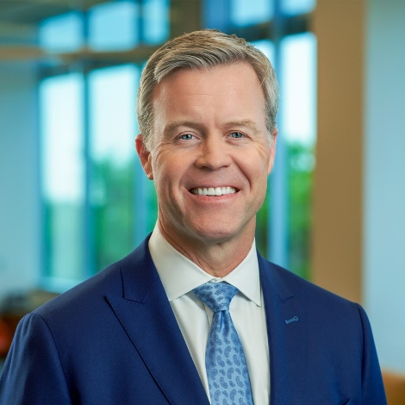

Based in Austin, Texas, Scott Bosworth is Head of Dimensional Fund Advisor’s Speakers Bureau. In addition to being a frequent presenter at Dimensional conferences and industry events, he manages the firm’s primary team of speakers and helps develop messaging and presentation content around key investment concepts. Scott began his career at Dimensional in 1996 as a Portfolio Manager in Santa Monica and during his time with the firm, has worked with both institutional and wealth advisory clients. He was most recently Head of Dimensional’s Enterprise Group, a team that manages the firm’s largest and most complex advisory relationships.